***PAAREES PERFUMES***

***Christian Diors***

***FOR MEN***

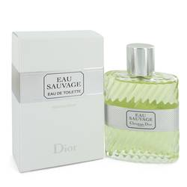

# *Eau Sauvage*

***Description:***

Eau Sauvage by Christian Dior Cologne. Show them your wild side and get the attention you deserve courtesy of Eau Sauvage for men. Introduced in 1966, this sultry men's fragrance features the aggressive blend of lemon, bergamot, basil, vetiver and rosemary notes to create a provocative aroma that stays with you for hours after use. This seductive scent from Christian Dior accentuates your untamed side while emphasizing your refined qualities. Choose Eau Sauvage whenever you need a versatile fragrance that complements your active lifestyle.